Experiment No. 1
Generation and Classification of Continuous-Time and Discrete-Time Signals
OBJECTIVE:
(i) To generate and visualize basic continuous-time signals such as unit step, unit impulse, ramp, sinusoidal, and exponential signals, and to classify them as periodic/non-periodic, even/odd and energy/power signals.
(ii) To generate and visualize basic discrete-time signals, analyze their amplitude and time-index characteristics, and classify them by periodicity, symmetry and energy/power.
(i) AIM: To generate and visualize basic continuous-time signals such as unit step, unit impulse, ramp, sinusoidal, and exponential signals.
Software / Laboratory Environment: MATLAB
Theory
A continuous-time signal x(t) is defined for every real value of t. A MATLAB simulation approximates it by sampling on a fine grid t = −1:0.001:1 (step Δt = 1 ms). The ideal impulse cannot be represented numerically, so it is approximated by a single-sample pulse of height 1/Δt and width Δt (unit area); it is drawn with unit height. Signals are classified as follows:
Signal | Expression | Periodic? | Energy / Power | Symmetry
Unit impulse | δ(t); ∫δ(t)dt = 1 | Non-periodic | Neither (idealised) | Even
Unit step | u(t) = 1 for t ≥ 0 | Non-periodic | Power (P = 1/2) | Neither
Unit ramp | r(t) = t·u(t) | Non-periodic | Neither | Neither
Decaying exponential | e^(−at)·u(t), a = 2 | Non-periodic | Energy (E = 1/2a) | Neither
Growing exponential | e^(at)·u(t), a = 2 | Non-periodic | Neither (unbounded) | Neither
Sinusoid | A·sin(2πf₀t), A = 2, f₀ = 5 Hz | Periodic, T = 1/f₀ = 0.2 s | Power (P = A²/2 = 2) | Odd

Experimental Procedure
- Define a continuous time vector with a sufficiently small simulation interval (Δt = 0.001 s).
- Generate unit impulse, unit step, ramp, decaying and growing exponential, and sinusoidal signals.
- Plot each waveform against time using suitable amplitude and time scales, with labelled axes.
- Measure amplitude, frequency and period of the sinusoid (rising zero-crossing method with linear interpolation).
- Compute impulse area, energy of the decaying exponential and average power of the sinusoid using trapz and mean.
- Compare the simulated results with the theoretical expressions; record observations and justify the signal characteristics.
Algorithm
- Start. Set Δt, create t = −1:Δt:1 and set A = 2, f₀ = 5 Hz, a = 2.
- Impulse: δ(t) = 1 where |t| < Δt/2, else 0. Step: u(t) = 1 where t ≥ −Δt/2, else 0 (tolerance avoids floating-point error at t = 0).
- Ramp: r(t) = t·u(t). Exponentials: e^(−at)u(t) and e^(at)u(t). Sinusoid: x(t) = A·sin(2πf₀t).
- Find indices where x(t) changes from negative to non-negative; interpolate the crossing instants t_z; T = mean(diff(t_z)); f = 1/T.
- Evaluate area = ∫δ dt, energy = ∫|x|²dt and power = mean(x²) numerically.
- Plot all six signals in a 3 × 2 subplot grid, print the measurements and stop.
MATLAB Coding
% Experiment 1(i): Generation of Continuous-Time Signals
clc; clear; close all;

%% Parameters
dt = 0.001; % simulation step (s)
t = -1:dt:1; % time vector
A = 2; f0 = 5; a = 2; % amplitude, frequency (Hz), exponent

%% Signal generation
imp = double(abs(t) < dt/2); % impulse (drawn with unit height, true height = 1/dt)
step = double(t >= -dt/2); % unit step
ramp = t .* step; % unit ramp
expDec = exp(-a*t) .* step; % decaying exponential
expGro = exp( a*t) .* step; % growing exponential
sinSig = A*sin(2*pi*f0*t); % sinusoid

%% Measurements (period, frequency, area, energy, power)
idx = find(sinSig(1:end-1) < 0 & sinSig(2:end) >= 0); % rising zero crossings
tz = t(idx) - sinSig(idx)*dt ./ (sinSig(idx+1) - sinSig(idx));
T = mean(diff(tz)); % measured period
fm = 1/T; % measured frequency
areaImp = trapz(t, imp/dt); % area of the impulse approximation
Ed = trapz(t(step==1), expDec(step==1).^2); % energy of e^(-at)u(t)
Ps = mean(sinSig.^2); % average power of the sinusoid

fprintf('Peak amplitude of sinusoid = %.4f\n', max(sinSig));
fprintf('Measured period T = %.4f s\n', T);
fprintf('Measured frequency f0 = %.4f Hz\n', fm);
fprintf('Area of impulse (approx.) = %.4f\n', areaImp);
fprintf('Energy of exp(-2t)u(t) = %.4f (theory (1-e^-4)/4 = %.4f)\n', Ed, (1-exp(-4))/4);
fprintf('Average power of sinusoid = %.4f (theory A^2/2 = %.4f)\n', Ps, A^2/2);

%% Plots
figure(1);
subplot(3,2,1); plot(t,imp,'LineWidth',1.2); grid on; axis([-1 1 -0.2 1.2]);
title('Unit Impulse \delta(t)'); xlabel('t (s)'); ylabel('Amplitude');

subplot(3,2,2); plot(t,step,'LineWidth',1.2); grid on; axis([-1 1 -0.2 1.2]);
title('Unit Step u(t)'); xlabel('t (s)'); ylabel('Amplitude');

subplot(3,2,3); plot(t,ramp,'LineWidth',1.2); grid on; axis([-1 1 -0.1 1.1]);
title('Unit Ramp r(t) = t u(t)'); xlabel('t (s)'); ylabel('Amplitude');

subplot(3,2,4); plot(t,expDec,'LineWidth',1.2); grid on; axis([-1 1 -0.1 1.1]);
title('Decaying Exponential e^{-2t}u(t)'); xlabel('t (s)'); ylabel('Amplitude');

subplot(3,2,5); plot(t,expGro,'LineWidth',1.2); grid on; xlim([-1 1]);
title('Growing Exponential e^{2t}u(t)'); xlabel('t (s)'); ylabel('Amplitude');

subplot(3,2,6); plot(t,sinSig,'LineWidth',1.2); grid on; axis([-1 1 -2.5 2.5]);
title('Sinusoid 2sin(2\pi\cdot5t), T = 0.2 s'); xlabel('t (s)'); ylabel('Amplitude');

Command Window Output
>> exp1_continuous
Peak amplitude of sinusoid = 2.0000
Measured period T = 0.2000 s
Measured frequency f0 = 5.0000 Hz
Area of impulse (approx.) = 1.0000
Energy of exp(-2t)u(t) = 0.2454 (theory (1-e^-4)/4 = 0.2454)
Average power of sinusoid = 1.9990 (theory A^2/2 = 2.0000)

Input and Output Graphs
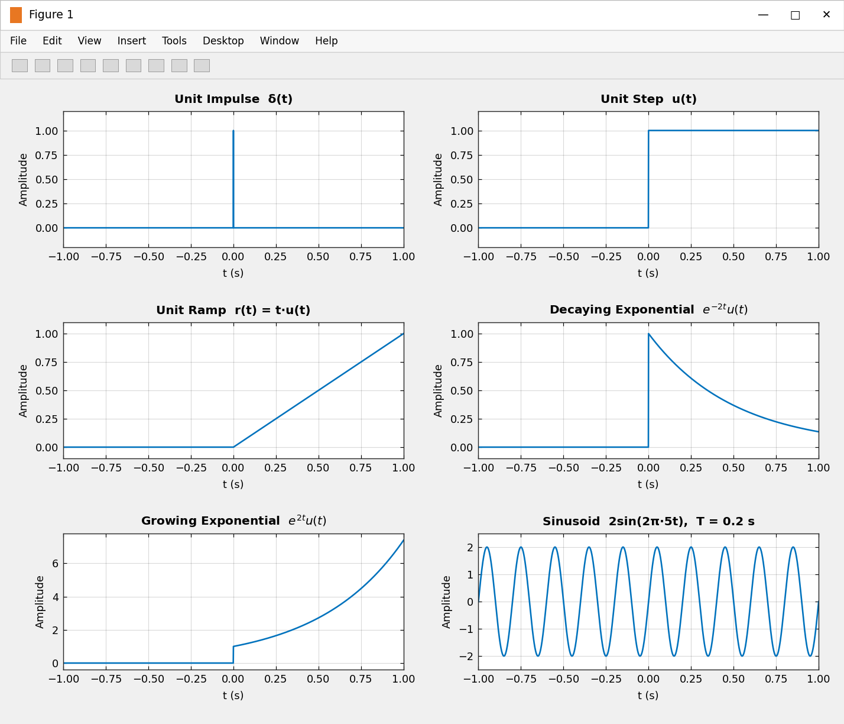
Figure 1: Continuous-time signals – unit impulse, unit step, ramp, decaying and growing exponential, and sinusoid.
Results
Parameter | Theoretical | Measured / Simulated | Remark
Sinusoid amplitude | 2 | 2.0000 | Match
Period T | 0.2 s | 0.2000 s | Match
Frequency f₀ | 5 Hz | 5.0000 Hz | Match
Impulse area | 1 | 1.0000 | Match
Energy of e^(−2t)u(t), 0 ≤ t ≤ 1 | 0.2454 | 0.2454 | Match
Average power of sinusoid | 2 | 1.9990 | Error ≈ 0.05 % (finite window, endpoint sample)

Observations
- The impulse is non-zero only at t = 0, and its numerical area equals 1.
- The unit step switches from 0 to 1 at t = 0 and stays constant; the ramp rises linearly with unit slope for t ≥ 0.
- e^(−2t)u(t) jumps to 1 at t = 0 and decays towards zero (energy signal), whereas e^(2t)u(t) grows without bound (neither energy nor power).
- The sinusoid has peak amplitude 2, completes 5 cycles per second (T = 0.2 s) and is odd and periodic.
(ii) AIM: To generate and visualize basic discrete-time signals and analyze their amplitude and time-index characteristics.
Software / Laboratory Environment: MATLAB
Theory
A discrete-time signal x[n] is defined only at integer n. A sinusoid x[n] = A·sin(2πf₀n) is periodic only if f₀ = p/N is a rational number, in which case the fundamental period is N (in lowest terms). Any sequence can be decomposed as x[n] = xₑ[n] + xₒ[n], where xₑ[n] = (x[n] + x[−n])/2 is even and xₒ[n] = (x[n] − x[−n])/2 is odd.
Sequence | Expression | Periodic? | Energy / Power | Symmetry
Unit impulse | δ[n] = 1 at n = 0 | Non-periodic | Energy (E = 1) | Even
Unit step | u[n] = 1 for n ≥ 0 | Non-periodic | Power (P = 1/2) | Neither
Unit ramp | r[n] = n·u[n] | Non-periodic | Neither | Neither
Decaying exponential | (0.8)ⁿ·u[n] | Non-periodic | Energy (E = 1/(1−0.64) = 2.7778) | Neither
Growing exponential | (1.1)ⁿ·u[n] | Non-periodic | Neither (unbounded) | Neither
Sinusoid | 2·sin(2π·0.1·n) | Periodic, N = 10 | Power (P = A²/2 = 2) | Odd

Experimental Procedure
- Define the integer sample index n = −20:20.
- Generate unit impulse, unit step, ramp, decaying and growing exponential, and sinusoidal sequences.
- Display each sequence using a stem plot.
- Determine sample amplitudes and the period of the sinusoid using rat(f₀).
- Classify the sequences as periodic/non-periodic and even/odd; compute the energy of the decaying exponential.
- Compare the generated samples with theoretical values and record observations.
Algorithm
- Start. Create n = −20:20 and set A = 2, f₀ = 0.1, r = 0.8, g = 1.1.
- δ[n] = (n == 0); u[n] = (n ≥ 0); r[n] = n·u[n]; rⁿu[n] and gⁿu[n]; x[n] = A·sin(2πf₀n).
- Periodicity test: [p, N] = rat(f₀). A rational f₀ gives the period N; an irrational ω₀/2π (e.g. sin(n)) means non-periodic.
- Fold the sequence with fliplr to obtain x[−n]; form xₑ and xₒ and verify xₑ + xₒ = x.
- Compute the energy E = Σ|x[n]|², plot Figures 2 and 3 with stem(…,'filled'), print the results and stop.
MATLAB Coding:
% Experiment 1(ii): Generation and Classification of Discrete-Time Signals
clc; clear; close all;

%% Parameters
n = -20:20; % integer sample index
A = 2; f0 = 0.1; % amplitude, digital frequency (cycles/sample)
r = 0.8; g = 1.1; % decay base (|r|<1) and growth base (g>1)

%% Sequence generation
imp = double(n == 0); % unit impulse
step = double(n >= 0); % unit step
ramp = n .* step; % unit ramp
expDec = r.^n .* step; % decaying exponential
expGro = g.^n .* step; % growing exponential
sinSig = A*sin(2*pi*f0*n); % discrete sinusoid

%% Classification
[p, N] = rat(f0); % f0 = p/N rational -> periodic with period N
x = expDec; xr = fliplr(x); % xr[n] = x[-n] (n is symmetric about 0)
xe = (x + xr)/2; % even part
xo = (x - xr)/2; % odd part
Ex = sum(abs(x).^2); % energy of (0.8)^n u[n]

fprintf('Fundamental period of 2sin(2*pi*0.1n) N = %d\n', N);
fprintf('sin(n): omega0/(2*pi) = %.4f (irrational) -> non-periodic\n', 1/(2*pi));
fprintf('Energy of (0.8)^n u[n] = %.4f (theory 1/(1-0.64) = %.4f)\n', Ex, 1/(1-r^2));
fprintf('Max |x_e[n] + x_o[n] - x[n]| = %.1e\n', max(abs(xe + xo - x)));
fprintf('Is x_e[n] even? %d Is x_o[n] odd? %d\n', isequal(xe,fliplr(xe)), isequal(xo,-fliplr(xo)));

%% Figure 2: basic sequences
figure(2);
subplot(3,2,1); stem(n,imp,'filled'); grid on; ylim([-0.2 1.2]);
title('Unit Impulse \delta[n]'); xlabel('n'); ylabel('Amplitude');

subplot(3,2,2); stem(n,step,'filled'); grid on; ylim([-0.2 1.2]);
title('Unit Step u[n]'); xlabel('n'); ylabel('Amplitude');

subplot(3,2,3); stem(n,ramp,'filled'); grid on;
title('Unit Ramp r[n] = n u[n]'); xlabel('n'); ylabel('Amplitude');

subplot(3,2,4); stem(n,expDec,'filled'); grid on;
title('Decaying Exponential (0.8)^n u[n]'); xlabel('n'); ylabel('Amplitude');

subplot(3,2,5); stem(n,expGro,'filled'); grid on;
title('Growing Exponential (1.1)^n u[n]'); xlabel('n'); ylabel('Amplitude');

subplot(3,2,6); stem(n,sinSig,'filled'); grid on;
title('Discrete Sinusoid 2sin(2\pi\cdot0.1n), N = 10'); xlabel('n'); ylabel('Amplitude');

%% Figure 3: periodicity and even/odd decomposition
figure(3);
subplot(2,2,1); stem(n,sinSig,'filled'); grid on;
title('Periodic: 2sin(2\pi\cdot0.1n), N = 10'); xlabel('n'); ylabel('Amplitude');

subplot(2,2,2); stem(n,sin(n),'filled'); grid on;
title('Non-periodic: sin(n), \omega_0 = 1 rad'); xlabel('n'); ylabel('Amplitude');

subplot(2,2,3); stem(n,xe,'filled'); grid on;
title('Even part x_e[n] of (0.8)^n u[n]'); xlabel('n'); ylabel('Amplitude');

subplot(2,2,4); stem(n,xo,'filled'); grid on;
title('Odd part x_o[n] of (0.8)^n u[n]'); xlabel('n'); ylabel('Amplitude');

Command Window Output
>> exp1_discrete
Fundamental period of 2sin(2*pi*0.1n) N = 10
sin(n): omega0/(2*pi) = 0.1592 (irrational) -> non-periodic
Energy of (0.8)^n u[n] = 2.7775 (theory 1/(1-0.64) = 2.7778)
Max |x_e[n] + x_o[n] - x[n]| = 0.0e+00
Is x_e[n] even? 1 Is x_o[n] odd? 1

Input and Output Graphs
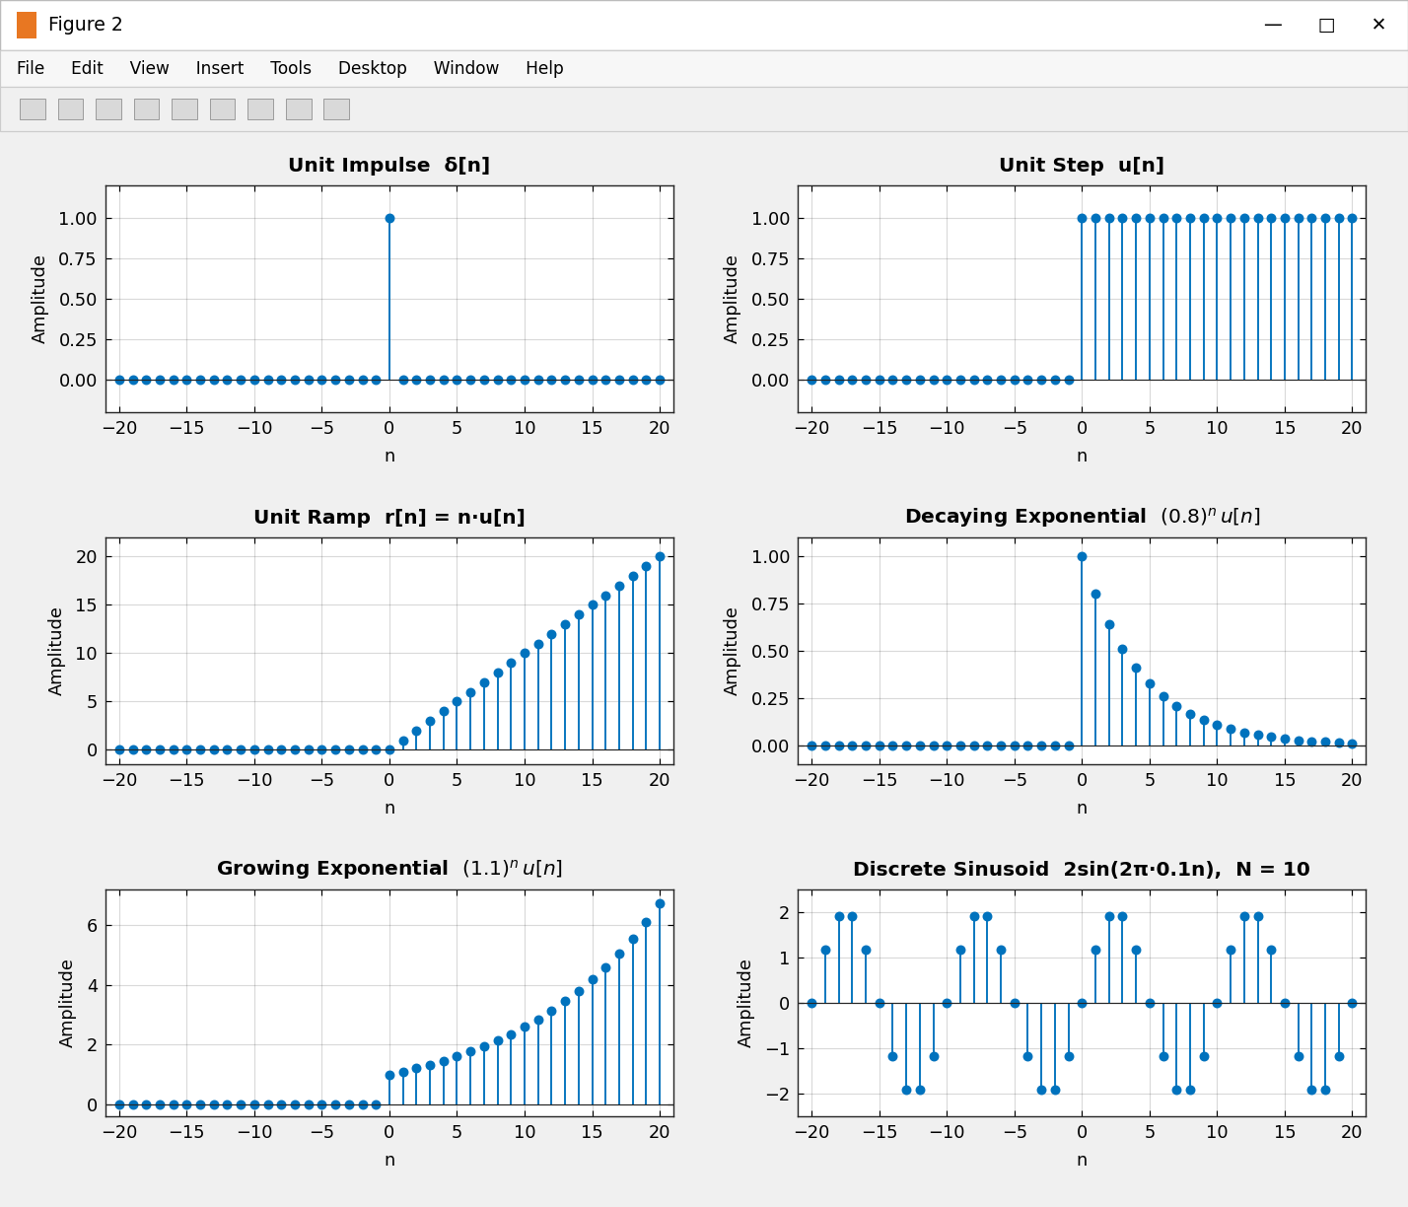
Figure 2: Discrete-time sequences – impulse, step, ramp, decaying and growing exponential, and sinusoid.
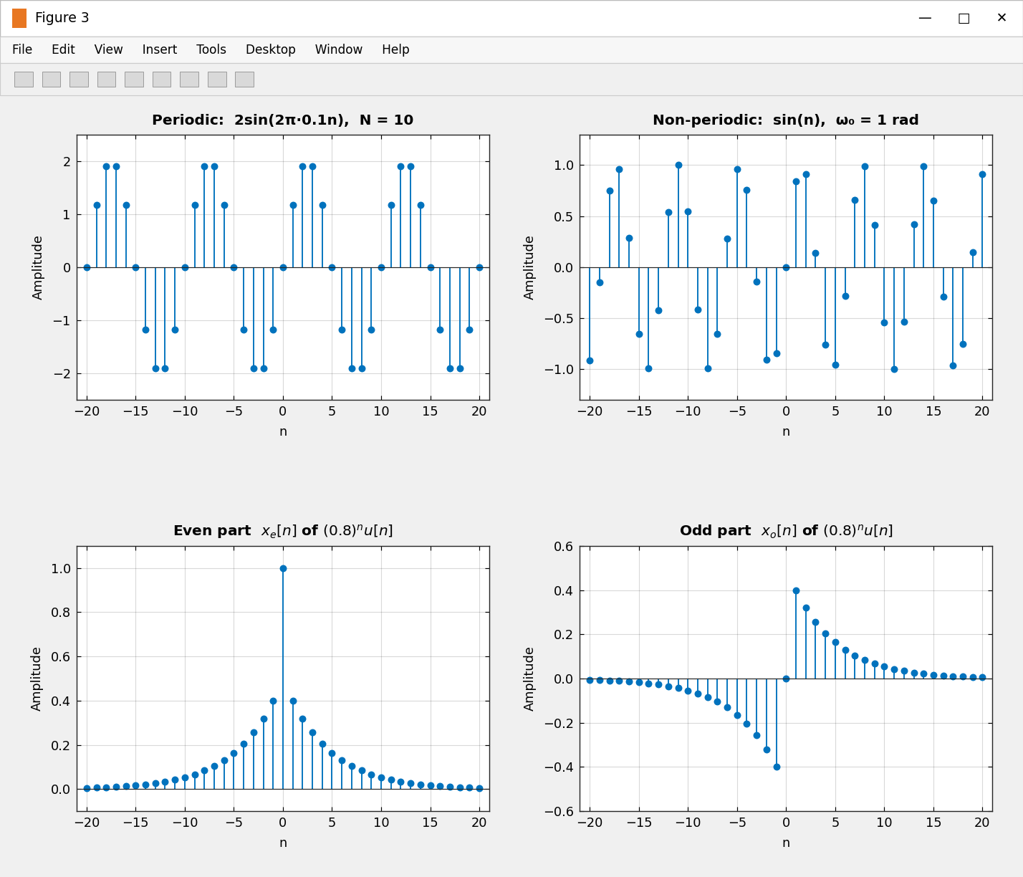
Figure 3: Classification – periodic vs. non-periodic sequences and even/odd decomposition of (0.8)ⁿu[n].
Results
Parameter | Theoretical | Measured / Simulated | Remark
Period of 2sin(2π·0.1n) | N = 10 | N = 10 | Periodic (f₀ rational)
sin(n) periodicity | ω₀/2π = 0.1592 irrational | Non-periodic | No integer N exists
Energy of (0.8)ⁿu[n] | 2.7778 | 2.7775 | Truncation to n ≤ 20
max|xₑ[n]+xₒ[n]−x[n]| | 0 | 0.0e+00 | Decomposition exact
xₑ even, xₒ odd | True / True | 1 / 1 | Verified

Observations
- δ[n] is 1 only at n = 0; u[n] and r[n] are zero for n < 0, so they are causal sequences.
- (0.8)ⁿu[n] decays geometrically (energy 2.7778), while (1.1)ⁿu[n] grows without bound.
- 2sin(2π·0.1n) repeats every N = 10 samples, whereas sin(n) never repeats because ω₀/2π is irrational.
- The even part of (0.8)ⁿu[n] is symmetric about n = 0 and the odd part is antisymmetric; their sum reproduces the original sequence exactly.
Conclusion
Basic continuous-time and discrete-time signals were generated in MATLAB and their amplitude, period, frequency, energy and power were measured. The simulated values agree with the theoretical results, and the signals were successfully classified as periodic/non-periodic, even/odd and energy/power signals.

